School District 57 is providing an opportunity for schools to support student learning through Learning Team Innovation Grants. This provides teachers and administrators new ways to explore innovative practices through collaboration and teamwork, as well as…

- Shared Opportunity between schools and the Curriculum & Innovation Department
- Aligned with the goals in your School Plan for Student Success and SD57 Strategic Plan
Aligned to the BC Curriculum (Big Ideas), First Peoples Principles of Learning, and Assessment for Learning
- Learning resources, programs, materials and supplies developed through the LTIG remain the property of School District No. 57.
- Powerpoint Summary uploaded to the SD57 Curriculum Hub

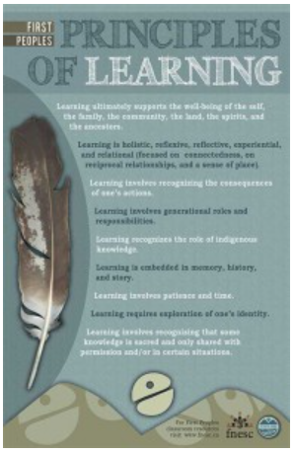
SD57 Learning Team Innovation Grants support the development of exemplary teaching and contribute to program improvement that align with the SD57 Strategic Plan.

SD57 2016-2021 Strategic Plan https://curriculum.gov.bc.ca/

First Peoples Principles of Learning

Selected Collaborative Learning Teams will:

- Be honoured and recognized with their work being placed on the Curriculum Hub.

- Provide an estimate of funds that may be required for your project to your school principal prior to submitting grant application. Funds for resources are the sole responsibility of the school and should be pre-approved. The Curriculum & Innovation Dept. will not be providing any funding for resources.

- Submit Supplementary Pay forms each month, as applicable, to your school secretary. Funds will be paid out of the school account. Upon completion of the grant project, Curriculum & Innovation will reimburse the approved lump sum amount to the school as a budget transfer. (A specific email outlining process will be sent to schools Principals, Business Managers and Secretary.)

- Prepare 1-page written summary (information about meetings) as well as PowerPoint Summary as required at the completion of the grant. (A PowerPoint Summary will replace both the written project summary and presentation slides). They must be submitted the week of March 15-19th for funds to be transferred to the school.

- Submit a Mid-Point Update Report by January 8th. There is a form that will be sent to fill out.

- VERY IMPORTANT - Upon approval, your LTIG will be given a number - The name of your Grant and the number assigned must be included in the subject line of all email correspondence (ex LTIG #17 - Literacy Learning Team)

IMPORTANT INFORMATION and DUE DATES

CHECK ALL BOXES
☐Application form due Oct 9th – Email to Julie Begg (jbegg@sd57.bc.ca)

☐Supplementary Pay (paid at 1/300) will only be paid for work done 1-hr after dismissal & on weekends. If working with more than one group, days can only be submitted once if meetings overlap. Different working groups (LTIG 0r otherwise) cannot be combined unless given prior approval.

☐Supplementary Pay forms must be submitted BY THE END OF EACH MONTH for processing. Submit directly to your school secretary (for Principal signature and school account code). Please ensure forms are filled out correctly to avoid delays.

☐Mid-point update FORM to be submitted January 8, 2021. (Link will be provided).

☐PowerPoint Summary emailed to Julie Begg 2021 week of March 15-19 (with prior approval an extension may be given until April 7th 2021).

☐ With Outlook, all emails must include LTIG, your LTIG name and number in the subject line (provided on approval letter) in order for information to be read in a timely manner. EX: LTIG - #17 Learning Literacy Team

☐Resources should be purchased by the schools using school credit cards and PO’s.
All purchased resources remain the property of SD57. C&I will not be responsible for funding resources.

☐All participants AND Principals signatures must be on the same application form. Only one application is to be submitted per project. (Lead will be responsible for scanning the application to all Principals for signatures.)

Important Information Regarding Supplementary Pay Forms

- Supplementary Pay is paid at 1/300 of the appropriate salary grid.
- Supplementary Pay is paid by full days or half days, not hours.
- Supplementary Pay forms need to be filled out and handed in MONTHLY, no exceptions. (As per Supplementary Service Guidelines and Practises).
- Only 1 date allowed on each form with only 1 box ticked (half day or full day).
** (this has changed from last year where more than 1 date was allowed on the form. Payroll requires separate forms for each date).
- The Number and Title of the LTIG should be indicated in the “Event, Grant, Activity Name” box
- Forms are submitted directly to your school secretary for Principal approval and school account code.

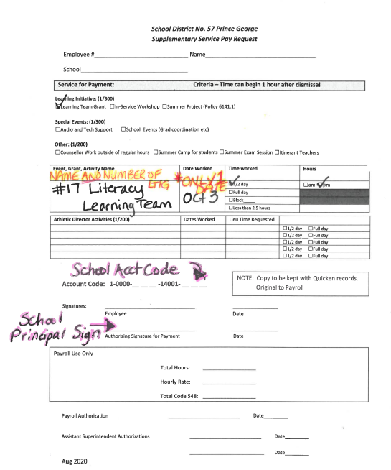
IMPORTANT
Hand in at end of EACH month
ONLY 1 date per Supplementary Pay Form. More than 1 date requires filling out another form.

For example: If you worked 2 full days in month of Dec – 2 Supplementary Pay Forms need to be filled out with 1 date on each form. (Full day box ticked).

EMAIL APPLICATION TO: JULIE BEGG ONLY FULLY SIGNED APPLICATIONS WILL BE REVIEWED.

Title of Project: Click or tap here to enter text.

Project Description (this is the idea): Click or tap here to enter text.

Overall Goal – Alignment to Strategic Plan (Assessment, Inquiry, Truth & Reconciliation: Calls to Action 62 & 63)
Click or tap here to enter text.

Specific Goals – (this is what we hope will happen in relation to student learning) Click or tap here to enter text.

Rationale - (this is why we are undertaking this project) Click or tap here to enter text.

Achievement Strategies - (this is how we will get there) - Click or tap here to enter text.

Quality Indicators Evidence - (here is how we will measure our success, how we know if we achieved our intended outcomes) -
Click or tap here to enter text.

Timeline of Project (this is our Action Plan, when we plan to meet etc.) -
Click or tap here to enter text.

TEAM LEAD(s): | SCHOOL | TOTAL DAYS  REQUESTED | LI USE ONLY  APPROVED DAYS | PRINCIPAL SIGNATURE
Click or tap here to enter text. | Click or tap here to enter text. | Click or tap here to enter text.

TEAM MEMBERS | SCHOOL | TOTAL DAYS  REQUESTED | LI USE ONLY  APPROVED DAYS | PRINCIPAL SIGNATURE
Name: Signature: | Click or tap here to enter text. | Click or tap here to enter text.
Name: Signature | Click or tap here to enter text. | Click or tap here to enter text.
Name: Signature: | Click or tap here to enter text. | Click or tap here to enter text.
Name: Signature: | Click or tap here to enter text. | Click or tap here to enter text.
Name: Signature | Click or tap here to enter text. | Click or tap here to enter text.
Name: Signature | Click or tap here to enter text. | Click or tap here to enter text.
Name: Signature: | Click or tap here to enter text. | Click or tap here to enter text.
Name: Signature: | Click or tap here to enter text. | Click or tap here to enter text.

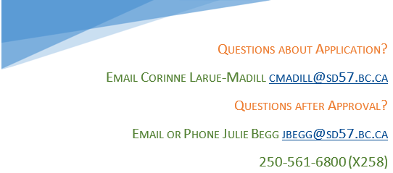

SUMMARIES – March 15-19, 2021

Email to Julie Begg (include LTIG - # & LTIG Name in Subject line)

The information you put in the subject line of your emails is important as we do not have a dedicated email address this year. This ensures your correspondence gets looked at in a timely manner and is easily searchable.

New this year the final summary will be requested in a different format. A one-page form is to be submitted with information on meetings (similar to Mid-Point Review, link to a form will be sent out).

The written summary with project details will be required in a PowerPoint, presentation ready, format. There will be no limit on slides as all of your summary information and resource links will be included in the slides.

1 Written team meeting information form must include: *

☐Meeting dates and times – must begin 1 hour after school dismissal or on weekends in order to earn Supplementary Pay
☐Attendance at each meeting
☐List of members that completed the project
☐List of members that could no longer participate after the initial application approval
*Similar to mid-point progress, link or form will be sent out.

1 PowerPoint summary must include: *

☐Project name
☐Group members
☐Vision
☐Purpose
☐Achievement Strategies
☐Quality Indicators for Evidence
☐Quality
☐FIPPA compliance
☐Next Steps
☐All resources used will be linked

*Summary will only be accepted in PowerPoint format, no limit on amount of slides.

